1. 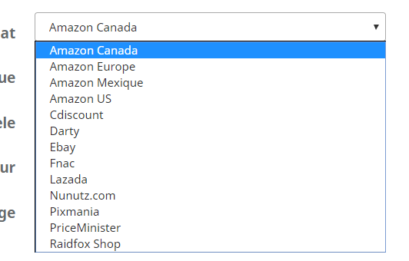

For Amazon/Cdiscount/PriceMinister/Lazada/Nunutz.com/Raidfox Shop

Need to send “FICHE DE RETOUR Price Minister.PDF”

1. For Darty/Macway/Fnac/Pixmania

Need to send “FICHE DE RETOUR SAV Fnac Darty Macway.pdf”

1. For Professionnal page, need to send “FICHE DE RETOUR SAV B2B.pdf”